Learner’s Dictionary

What is Learner’s Dictionary
# Source: AI Source: Provided by: [Data Path: Persons Table -> ID Column: 1, Name_En Column: Motasem Essam] -> From: [Chatgpt (GPT-4-turbo)] on [7/29/2025]
A Learner’s Dictionary is specifically designed for language learners (usually of English or another second language). It provides simplified definitions, clear usage examples, and helpful grammatical and collocational information to support vocabulary development and language acquisition.

🔹 Key Features of a Learner’s Dictionary
# Source: AI Source: Provided by: [Data Path: Persons Table -> ID Column: 1, Name_En Column: Motasem Essam] -> From: [Chatgpt (GPT-4-turbo)] on [7/29/2025]
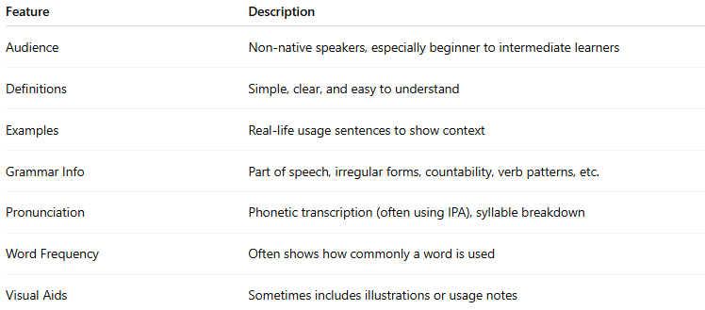
Feature | Description
Audience | Non-native speakers, especially beginner to intermediate learners
Definitions | Simple, clear, and easy to understand
Examples | Real-life usage sentences to show context
Grammar Info | Part of speech, irregular forms, countability, verb patterns, etc.
Pronunciation | Phonetic transcription (often using IPA), syllable breakdown
Word Frequency | Often shows how commonly a word is used
Visual Aids | Sometimes includes illustrations or usage notes

🔹 Examples of Learner’s Dictionaries
# Source: AI Source: Provided by: [Data Path: Persons Table -> ID Column: 1, Name_En Column: Motasem Essam] -> From: [Chatgpt (GPT-4-turbo)] on [7/29/2025]
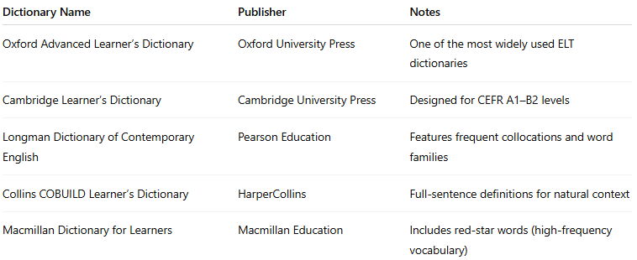
Dictionary Name | Publisher | Notes
Oxford Advanced Learner’s Dictionary | Oxford University Press | One of the most widely used ELT dictionaries
Cambridge Learner’s Dictionary | Cambridge University Press | Designed for CEFR A1–B2 levels
Longman Dictionary of Contemporary English | Pearson Education | Features frequent collocations and word families
Collins COBUILD Learner’s Dictionary | HarperCollins | Full-sentence definitions for natural context
Macmillan Dictionary for Learners | Macmillan Education | Includes red-star words (high-frequency vocabulary)

🔹 Advantages
# Source: AI Source: Provided by: [Data Path: Persons Table -> ID Column: 1, Name_En Column: Motasem Essam] -> From: [Chatgpt (GPT-4-turbo)] on [7/29/2025]
- Makes learning vocabulary accessible and practical
- Supports reading, writing, listening, and speaking skills
- Provides context, not just definitions
- Encourages independent language study

🔹 Use Cases
# Source: AI Source: Provided by: [Data Path: Persons Table -> ID Column: 1, Name_En Column: Motasem Essam] -> From: [Chatgpt (GPT-4-turbo)] on [7/29/2025]
- ESL/EFL education (English as a Second or Foreign Language)
- Self-study and classroom learning
- Test preparation (e.g., IELTS, TOEFL, Cambridge Exams)
- Developing writing and speaking fluency

